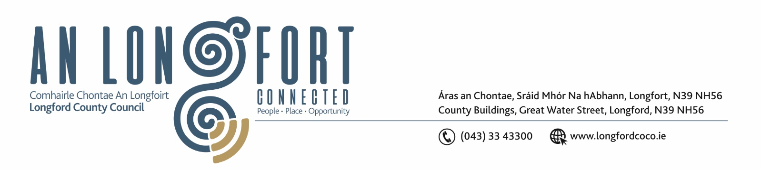
10th November 2021.

Chuig: Gach Ball don Chomhairle.

A Chomhairleoir,

You are requested to attend the Statutory Local Authority Budget Meeting of Longford County Council to be held in Council Chamber, Aras an Chontae, Longford/via Microsoft Teams on Monday, 22nd November 2021 at 3pm to transact business as set out on the agenda hereunder.

Mise le meas,

Ann Marie Mc Keon
________________
Ann Marie Mc Keon,
Meetings Administrator.

C L A R

Prayer before meeting.

- Consideration of 2022 Draft Budget.

